Fixing Report of takingmyclassesonline.com

Report # 3

Effective Dated: 30th October 2024.

Point # 1:

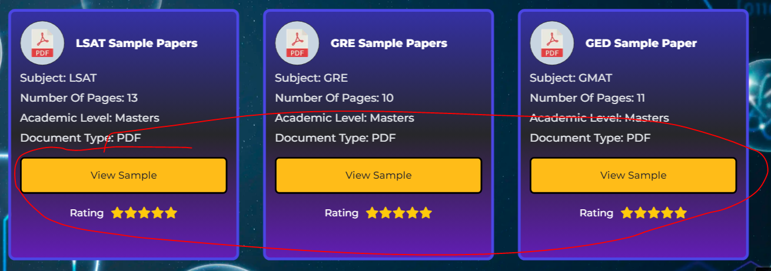

Note: CTA button not linked to the pages.

Point # 2:

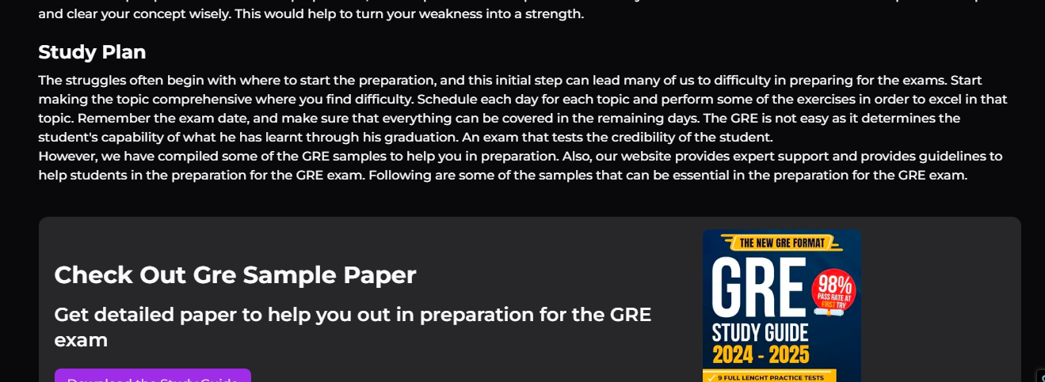

Note: Where are the sample links?

Point # 3:

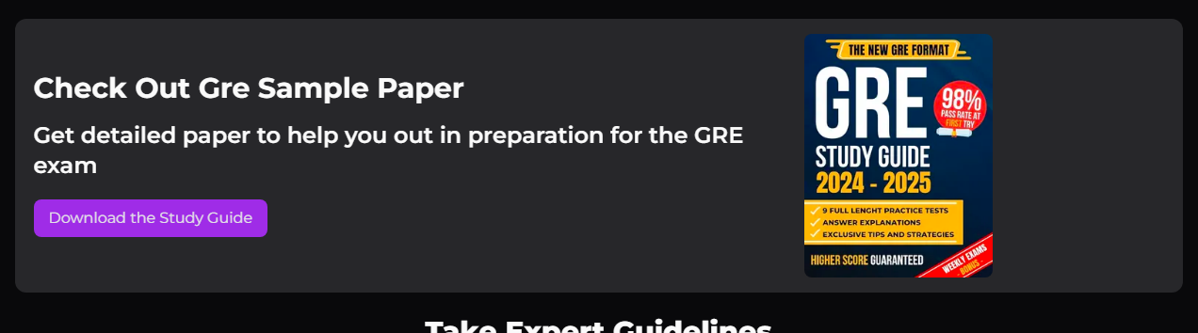

Note: You haven’t set the study guide on click!

Point # 4:

On every services page!

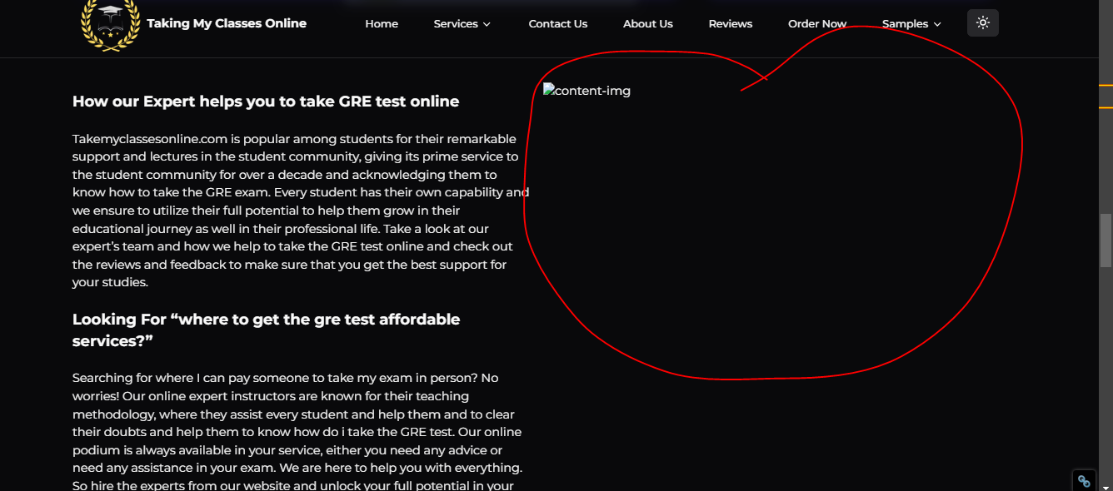

Note: Image not displays.